|  |  |  |  |
| --- | --- | --- | --- |
| **Branch: Instrumentation & Control Engineering** | | **Year:** Second Year | |
| **Division: C** | **Roll No: 04** | **GR Number: 11911180** | **Subject:** OOPS |
| **Assignment No:** | **Date of Submission: 29-04-2021** | **Student Full Name: Shaunak Sudhir Deshpande** | |

Aim: Create a C++ program to show the order of constructors and destructors. Implement all types of constructors.

Software Used: MinGW, VSCode

Code:

#include<iostream>

using namespace std;

class Parent

{

    public:

    Parent()

    {

        cout<<"Inside base class constructor (parent)\n\n";

    }

    ~Parent()

    {

        cout<<"Base class destructor called\n\n";

    }

};

class Child : public Parent

{

public:

    Child()

    {

        cout<<"Inside sub class constructor(child)\n\n";

    }

    ~Child()

    {

        cout<<"Child class destructor called\n\n";

    }

};

int main()

{

    Child obj;

    return 0;

}

Output:

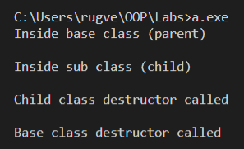

Analysis of Program:

In this program, we have two classes, Parent & Child respectively, and child inherits from parent. Each class has a user defined constructor and destructor. We want to understand the order in which the constructors are called, and the order in which the destructors are called when we create an object of the child class.

Conclusion:

From this code, we can see that when it comes to the order in which constructors are called, the order is:

Base class constructor called-🡪 Derived class constructor called.

But when it comes to the order in which destructors are called, the order is:

Derived class destructor called 🡪 Base class destructor called.